**Moulik Tammana**

**Q6. Change the native VLAN on a trunk port. Test for VLAN mismatches and troubleshoot.**

**A Native VLAN is the VLAN that carries untagged traffic on a trunk port in 802.1Q trunking.**

* **When a switch receives untagged frames on a trunk port, it assigns them to the native VLAN.**
* **By default, the native VLAN is VLAN 1 on most switches.**
* **Native VLANs help with backward compatibility for devices that do not support VLAN tagging.**

**What is the Use of VLANs?**

**A VLAN (Virtual Local Area Network) is a way to segment a network logically within a switch.**

1. **Network Segmentation:**

* **Separates devices logically even if they are on the same physical switch.**
* **Example: Separate VLANs for HR, IT, and Sales.**

1. **Improved Security:**

* **Prevents unauthorized communication between different VLANs.**
* **Example: Employees in VLAN 10 can’t access VLAN 20 without a router or firewall.**

1. **Reduces Broadcast Traffic:**

* **VLANs contain broadcast traffic within their VLAN.**
* **Example: If a broadcast is sent in VLAN 10, it won’t reach VLAN 20.**

1. **Better Network Management:**

* **Helps group devices based on function instead of physical location.**
* **Example: Printers in all floors can be in VLAN 30, regardless of switch location.**

**We cannot ping between two switches if the native VLANs are different on a trunk port because of VLAN mismatches.**

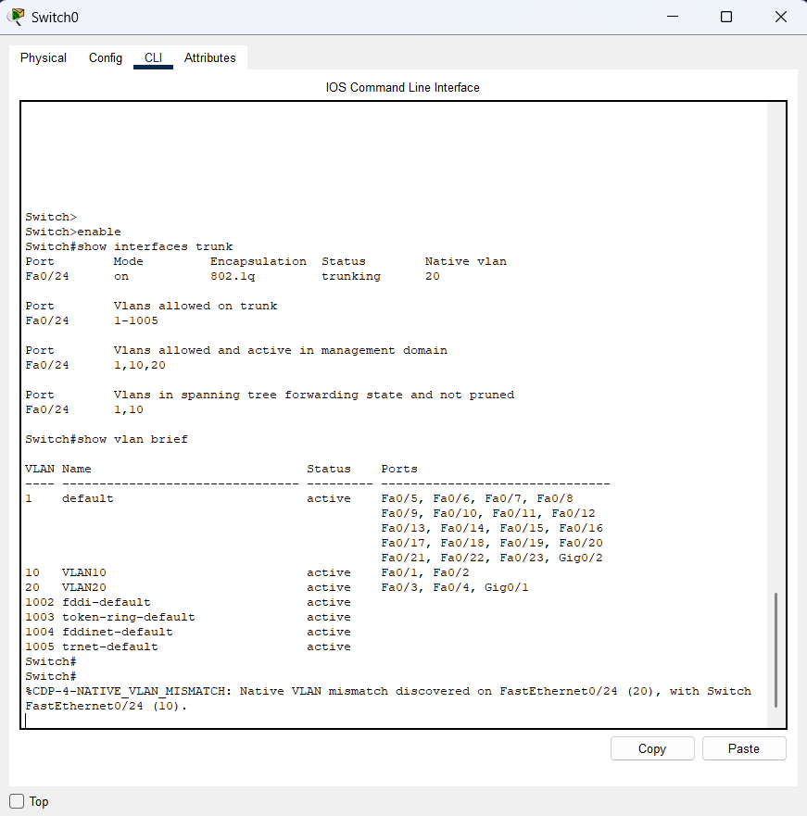

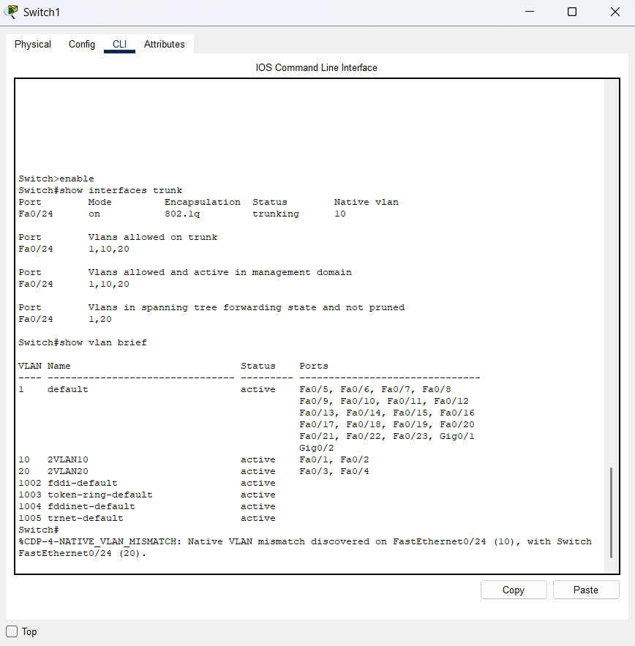

**We get this Native VLAN miss match error when during this situration.**



**Ping Failing:**

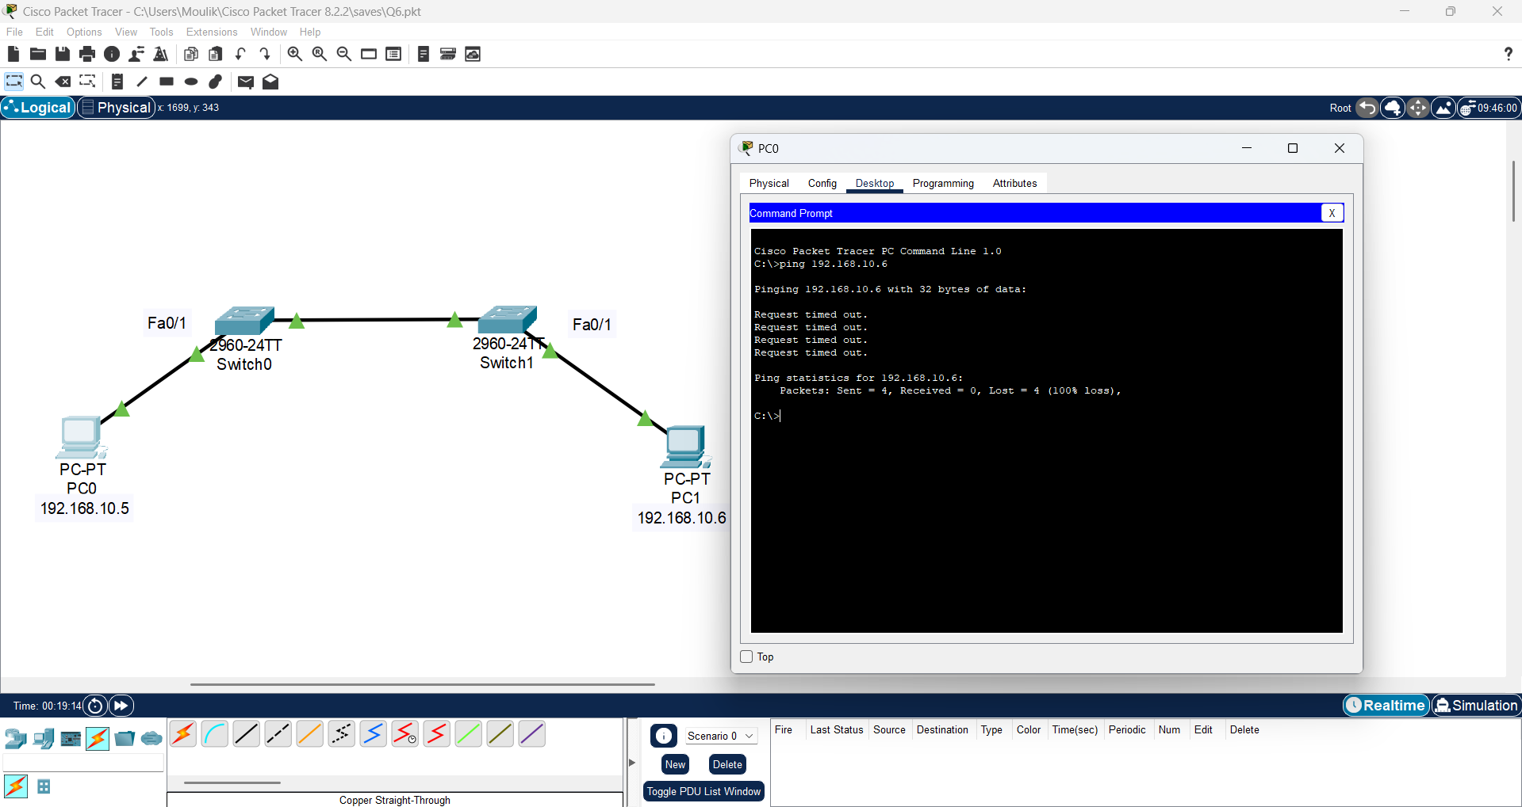

**When we change the Native VLAN in Router1 as VLAN 20:  
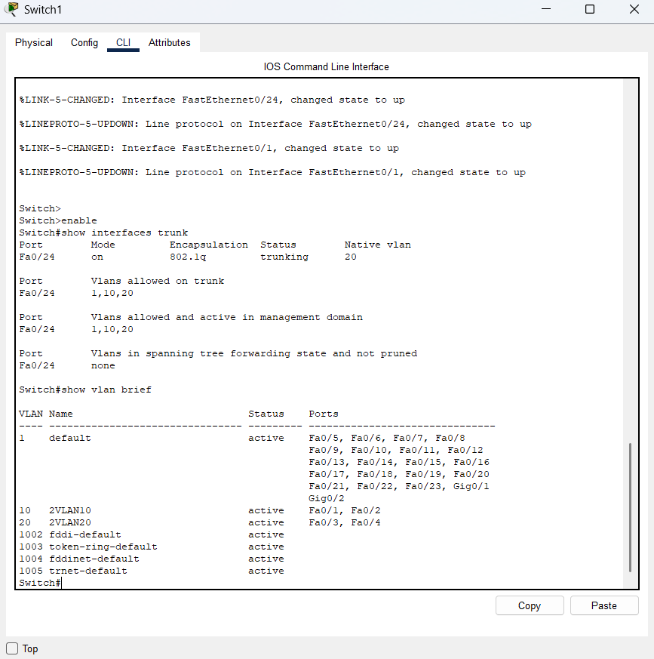**

**Ping is working:**

